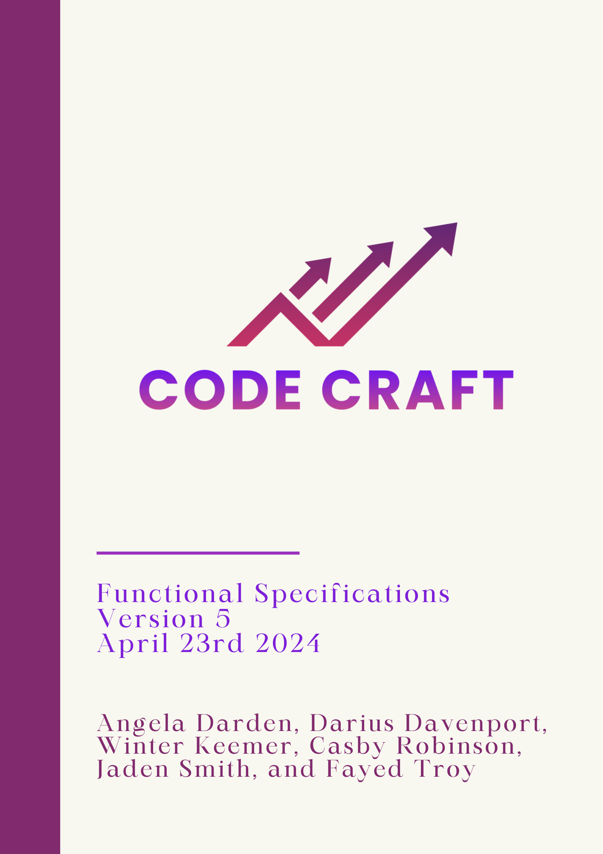

Table of Contents

**1.0 Introduction 3**

1.1 Goals and Objectives 3

1.2 Scope 3

**2.0 Product Feature 5**

2.1 Automation 5

2.2 Algorithm Use 5

2.3 Strategy 6

**3.0 Software Specification 7**

3.1 Jira Software 7

3.2 Google Docs 7

3.4 GitHub 8

3.5 Python 8

3.6 Alpaca 8

**4.0 Software Function Priorities 9**

4.1 Product Vision 9

**5.0 Functional Diagram 10**

5.1 Explanation 10

**6.0 Performance / Behavior Issues 12**

**7.0 Revision Log 13**

# 

# **1.0 Introduction**

Code Craft has been given a task to create an application for computerized stock trading, as well as create our own algorithm that will be used in the application. This document will outline all the requirements for this task.

## 1.1 Goals and Objectives

The goal of this project is to create an application that will help the user participate in stock trading. The algorithm that the team will create will be based on Trend Trading. Within the application, there will be three sections: Data Acquisitions, Strategy, and Trading Platform.

## 1.2 Scope

Code Craft has been given a synopsis of the tasks they must complete to create an application for computerized stock trading:

* Creating a Trend Trading algorithm
* Gathering data acquired from a real-time or near real-time streaming stock ticker feed, an RSS news feed, an Artificial Intelligence Large Language Model (e.g. ChatGPT), etc.
* Alpaca (our main Internet Trading Platform used to simulate a real trading platform)

The software project that is being undertaken is to develop a stock trading application based upon an algorithm using data acquired from a real-time or near real-time streaming stock ticker feed, an RSS news feed, an Artificial Intelligence Large Language Model (e.g. ChatGPT), etc. Our application will be executed any day from 9:30 am to 4:00 pm. Using Alpaca as our Internet Trading Platform, Code Craft will be funded $100,000 to use for our stock trading application. Project deliverables include documentation, individual and group timesheets and contributions, meeting minutes, and the software application itself. The group, Code Craft, will review and approve final documentation and application status before publishing. This project will not include option trading, and will only take a long or short position in a stock.

# **2.0 Product Featur**[**e**](https://docs.google.com/document/d/1BBxo9dRpmK8JyosBmDEO2jl7hdEcM4Zf/edit#heading=h.tyjcwt)

## 

## 2.1 Automation

The automation capabilities that the bot will have is the ability to buy, sell, and trade stocks. The automated program will connect to your Alpaca account, ask you for the stock you wish to purchase or sell, and analyze it. The analysis will operate based on the algorithm of SCA trading, which looks at past and current data to determine if the stock is on a downward or upward trend.

## 2.2 Algorithm Use

The algorithm will be based on Trend Strategy. Trend strategy is a fast-paced day trading strategy that involves quickly buying and selling shares of highly liquid securities in order to profit from small fluctuations in price, but we will be looking at trend reports throughout the day. The algorithm will utilize the API’s ability to connect to real-time stock updates. When talking about creating an algorithm you need to understand the direction in which the stock’s value moves. The value is typically shown next to the stock name. This value is a key indicator for decision-making because the algorithm is designed to determine whether it is positive or negative. The algorithm is told not to suggest selling the stock if the value is negative. This strategy is used in financial markets where a negative number normally means there is a decline in the price. Selling under these conditions might not be the best plan and could result in major losses. Using this algorithm, the bot should be able to run smoothly and throughout the day review the portfolio to see if it hits that mark of when it needs to sell the stock or need to buy more stocks to gain a bigger profit.

## 

## 2.3 Strategy

The strategy we will be using is Trend strategy. Trend strategy is an investment method that relies on examination of several datasets, including past stock prices, corporate performance indicators, and current market trends. The approach recognizes and profits from visible trends in the financial environment, with an emphasis on long-term movement of asset prices. Shareholders look to identify recurrent patterns or errors in past stock prices that could provide significant understanding into future market trends. We would like to incorporate the algorithm into the Alpaca API to make sure that trend trading is a good fit for the API. Also, make sure we can be successful using this algorithm to proceed our research into the final demonstration and have a final product for our client or our team trading stocks automatically. While incorporating our trend strategy, every week we will have a team member look at the sequences of the stocks rising or decreasing to have our personal data and make sure that we all have an understanding of how the stocks are supposed to be viewed and if there are any changes to be made we can manually correct them.

# **3.0 Software Specification**

## 

## 3.1 Jira Software

Jira Software is a popular project management and issue tracking tool developed by Atlassian. It is widely used for agile development, allowing teams to plan, track, and manage software development projects efficiently. We use Jira for forecasting throughout the iterations. Every iteration we will use this application to plan out every detail so we can have a finished product before every due date.

## 3.2 Google Docs

Google Docs, an online application provided by Google within its suite of office productivity tools known as Google Workspace operates in the cloud. Tailored for online document creation, editing, and sharing. During our project, most of our work will be done using this application. It is efficient to use this application so team members can write and edit documents at the same time.

3.3 Visual Studio IDE

Visual Studio, crafted by Microsoft, stands as an integrated development environment (IDE). This robust software application offers an extensive array of tools for software development, simplifying the process for developers to create, test, and deploy applications on diverse platforms. Using Visual Studios is a necessity. We use this mostly for code and this is how we run our code.

## 3.4 GitHub

We will be using Github for version control. GitHub allows for efficient and organized tracking of code changes. We have a main branch where everyone can see the most recent version of every code change.

## 3.5 Python

Python, characterized by its dynamic typing and high-level nature within an object-oriented paradigm, serves as a programming language. Python is the language that most group members are used to and can understand as well.

## 3.6 Alpaca

Buying and selling financial products, including stocks and cryptocurrencies, through the Alpaca platform—a commission-free trading API and brokerage service—is known as Alpaca Trading. Alpaca facilitates the development and implementation of algorithmic trading strategies by giving developers convenient access to trading functionalities and market data. The platform is well-liked by both individual traders and institutional investors due to its simplicity, transparency, and low-latency execution. By enabling users to incorporate trading features into their own apps, Alpaca's API promotes financial market innovation and automation.

# **4.0 Software Function Priorities**

## 

## 4.1 Product Vision

The vision for our product is to have an appealing interface for clients and have an easy transition from the interface to buying/trading stocks. To achieve this vision, our team is dedicated to designing an interface that not only catches the attention of our clients but also ensures a seamless transition from exploration to the execution of stock transactions. We understand the importance of an engaging platform, as it significantly contributes to the overall user experience. Our goal is to provide a platform that not only meets the functional requirements of buying and trading stocks but also exceeds user expectations in terms of accessibility and ease of use.

# **5.0 Functional Diagram**

# 

## 5.1 Explanation

We created this diagram to show the client how we want our program to run. You start by opening the code and when you run the code it automatically takes you to the welcome screen. After the welcome screen it will take you to another window, then that window lets you enter the stock of your choosing, how many shares of the stock you want to buy or sell, and the option to buy or sell. Next, you will have the decision to choose your order type (Market or Limit). Lastly, you will have the option to choose when you want the order to execute/expire (Day or Good-Til-Canceled). Once you buy whichever stock of your choosing, our bot will continuously monitor your stock portfolio, so when you gain money or lose money, it will always be aware about when to buy and when to sell. Our bot will be using trend charts to make sure that during the buy and sell stock phase it will know when the stock is about to drop or skyrocket.

# 

# **6.0 Performance / Behavior Issues**

# 

There are currently no unresolved performance or behavioral issues involving our backend or front end.

# 

# 

# 

# 

# 

# 

# 

# 

# 

# 

# 

# 

# 

# 

# 

# 

# 

# **7.0 Revision Log**

| Revision | By | Date | Description |
| --- | --- | --- | --- |
| 1.0 | Code Craft | 01/26/2024 | Functional Specifications for Iteration 2. |
| 2.0 | Code Craft | 02/15/2024 | Functional Specifications for Iteration 3. |
| 3.0 | Code Craft | 03/08/2024 | Functional Specifications for Iteration 4 |
| 4.0 | Code Craft | 03/28/2024 | Functional Specifications for Iteration 5. |
| 5.0 | Code Craft | 04/24/2024 | Functional Specifications for Final Presentation. |